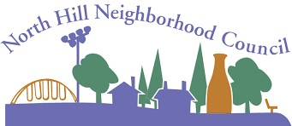
North Hill Neighborhood Council
Meeting Agenda for October 9, 2025
6:30-8:30pm
Note: Meetings are at the Four-Letter Word, Wall and Nebraska.
Agenda Item
Introductions
Proposed Agenda
Approve/Amend Minutes
Spokane Police Report
City Council Report
SpokaneScape
Office of Neighborhood Services
Traffic Calming/Cleanup Report
BSN / Budget Report
Community Assembly Report
Old Business
Updated Logo Design Vote
New Business
New Location
Post Office Landscaping
Neighborhood Concerns/Issues (Open Forum)
Presenter
Scot Webb
Scot Webb
Scot Webb
SPD
Zack or Kitty
Hannah Walker
Gabrielle Ryan
Mike/Scot
Dan Brown
Sara Bauer

Scot Webb

Scot Webb
Scot Webb

Time
5 min (6:30)
2 min (6:35)
3 min (6:37)
10 min (6:40)
10 min (6:50)
20 min (7:00)
10 min (7:20)
15 min (7:30)
5 min (7:45)
5 min (7:50)

10 min (7:55)
15 min (8:05)
5 min (8:20)
Next Meeting: November 13, 2025
Spokane City Website: my.spokanecity.org
North Hill Neighborhood Council:
https://my.spokanecity.org/neighborhoods/councils/north-hill/
www.northhill.spokaneneighborhoods.org
NHNC Email: northhillspokane@gmail.com

