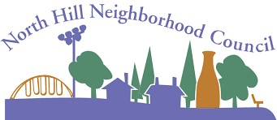
North Hill Neighborhood Council
Meeting Agenda for April 10, 2025
6:30-8:30pm
Note: Meetings are at the Four-Letter Word, Wall and Nebraska.
Agenda Item
Introductions
Proposed Agenda
Approve/Amend Minutes
Spokane Police Report
City Council Report
Office of Neighborhood Services
Traffic Calming/Cleanup Report
BSN / Budget Report
Community Assembly Report
Community Engagement Grant
Old Business
Street Art Design Approval
CDB Grant
New Business
Neighborhood Concerns/Issues (Open Forum)
Presenter
Scot Webb
Scot Webb
Scot Webb
SPD NRO
Zack or Kitty
Gabrielle Ryan
Mike Flahaven
Dan Brown
Sara Bauer
Scot Webb
Discussion
Update

Time
5 min (6:30)
2 min (6:35)
3 min (6:37)
10 min (6:40)
10 min (6:50)
15 min (7:00)
15 min (7:15)
5 min (7:30)
5 min (7:35)
30 min (7:40)
10 min (8:10)
10 min (8:20)

Next Meeting: May 8, 2025
Spokane City Website: my.spokanecity.org
North Hill Neighborhood Council:
https://my.spokanecity.org/neighborhoods/councils/north-hill/
www.northhill.spokaneneighborhoods.org
NHNC Email: northhillspokane@gmail.com

